**Assignment - 17 A Job Ready Bootcamp in C++, DSA and IOT**

String Basics in C Language

**1. Write a program to calculate the length of the string. (without using built-in method)**

#include<stdio.h>

int main()

{

char str[15]={"Aryankumar"};

int i,count=0;

printf("size of string is\n");

for(i=0;str[i];i++)

count++;

printf("%d",count);

return 0;

}

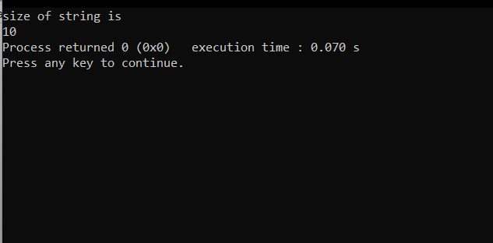

**2. Write a program to count the occurrence of a given character in a given string.**

#include<stdio.h>

int main()

{

char str[15]={"aryankumar"};

int i,count=0;

char ch='a';

for(i=0;str[i];i++)

{

if(str[i]==ch)

count++;

}

printf("%d",count);

return 0;

}

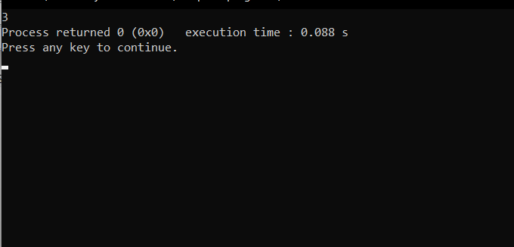

**3. Write a program to count vowels in a given string**

#include<stdio.h>

int main()

{

char str[15]={"welcome"};

int i,count=0;

for(i=0;str[i];i++)

{

if(str[i]=='a'||str[i]=='e'||str[i]=='i'||str[i]=='o'||str[i]=='u')

count++;

}

printf("The total vowels in given string is %d",count);

return 0;

}

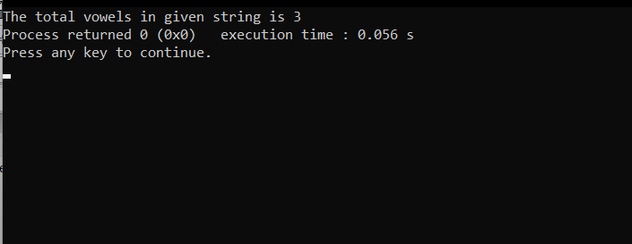

**4. Write a program to convert a given string into uppercase**

#include<stdio.h>

int main()

{

char str[20];

int i;

printf("Enter a string : ");

gets(str);

for(i=0;str[i];i++)

{

if(str[i] >= 'a' && str[i] <= 'z')

{

str[i]=str[i]-32;

}

}

printf("String in upper case is %s ",str);

return 0;

}

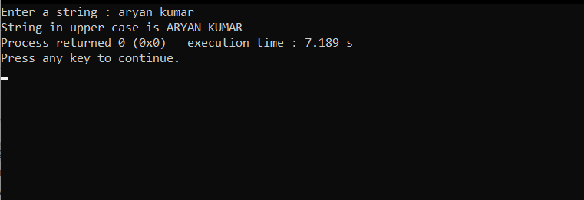

**5. Write a program to convert a given string into lowercase**

#include<stdio.h>

int main()

{

char str[20];

int i;

printf("Enter a string : ");

gets(str);

for(i=0;str[i];i++)

{

if(str[i] >= 'A' && str[i] <= 'Z')

{

str[i]=str[i]+32;

}

}

printf("String in lower case is %s ",str);

return 0;

}

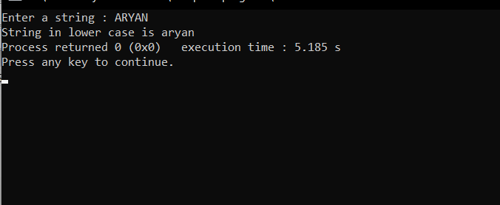

**6. Write a program to reverse a string.**

#include<stdio.h>

#include<string.h>

int main()

{

char str[]="Aryan",temp;

int i=0,j=strlen(str)-1;

while(i<=j)

{

temp=str[i];

str[i]=str[j];

str[j]=temp;

i++;

j--;

}

printf("Reverse of string is %s ",str);

return 0;

}

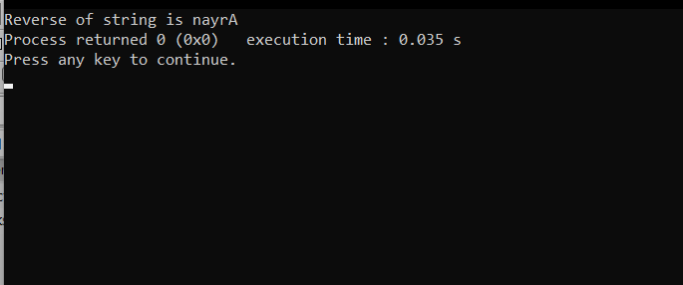

**7. Write a program in C to count the total number of alphabets, digits and special characters in a string.**

#include<stdio.h>

#include<string.h>

int main()

{

char str[20];

int i,alp=0,dig=0,spc=0;

printf("Enter a string : ");

gets(str);

for(i=0;str[i];i++)

{

if(str[i]>=65 && str[i]<=122)

alp++;

else if(str[i]>=48 &&str[i]<= 57)

dig++;

else

spc++;

}

printf("Total numbers of alphabet is %d \ndigit is %d \nspecial character is %d ",alp,dig,spc);

return 0;

}

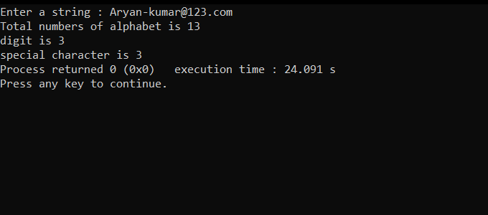

**8. Write a program in C to copy one string to another string**.

#include<stdio.h>

#include<string.h>

int main()

{

char str1[20],str2[20];

int i;

printf("Enter a string : ");

gets(str1);

for(i=0;str1[i];i++)

{

str2[i]=str1[i];

}

printf("After copy in another string %s : ",str2);

return 0;

}

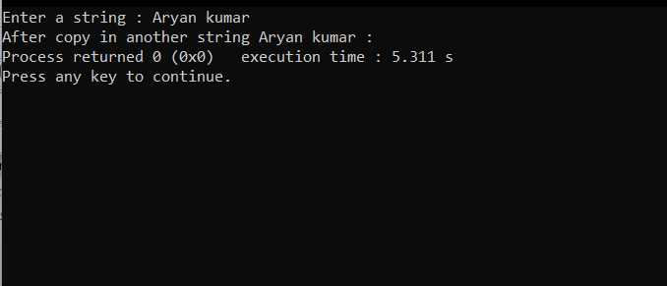

**9. Write a C program to sort a string array in ascending order.**

#include<stdio.h>

#include<string.h>

int main()

{

char str[100],ch;

int i,j,l;

printf("Enter a string : ");

gets(str);

l=strlen(str);

for(i=0;i<l;i++)

{

for(j=i+1;j<l;j++)

{

if(str[i]>str[j])

{

ch=str[i];

str[i]=str[j];

str[j]=ch;

}

}

}

printf("%s",str);

return 0;

}

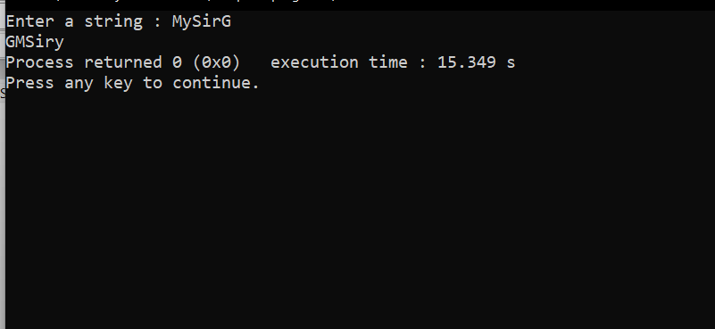

**10. Write a program in C to Find the Frequency of Characters**.

#include<stdio.h>

#include<string.h>

int main()

{

char str[]="Aryankumar",temp;

int freq[150]={0};

int i=0;

while(str[i]!='\0')

{

freq[str[i]]++;

i++;

}

for(i=0;i<150;i++)

{

if(freq[i]!=0)

printf("%c ==> %d\n",i,freq[i]);

}

return 0;

}

